Kendrick Lakes Elementary
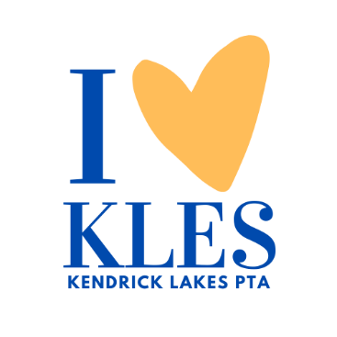
Think, achieve, become.
We, as Kendrick Lakes Dolphins, will THINK critically, to ACHIEVE academic excellence, and BECOME independent lifelong learners prepared to engage the world with empathy and integrity.

KLES General Membership Meeting - Virtual and In-Person
November 14, 2023

- Welcome (Natalie Andersen)

- Financials (Miriam Laws)
  - Budget Review
  - Financial Request Forms (Natalie Andersen)
    - Board Approved
      - Bowling Pins (Mr. Fish)
      - Walktober Funds (Mr. Fish)
      - Small Bouncy House (Mrs. Touher)
      - Battle of the Books (Mrs. Rubin)

- Fun Run 2024 (Natalie Andersen)
  - Booster Plus Level
    - Registration gift for kick-off
    - Classroom prizes
    - Communicate more regarding what the Fun Run Funds will be used for in the school.
    - Glow Run will be next year's theme. Oct.29th
    - Natalie motioned to approve the new Booster level, and the membership approved the new level for next year's Fun Run fundraiser.

- KLES Spirit Store (Sarah Hoover)
  - https://kendricklakesspiritwearfall23.itemorder.com/shop/home

- WatchD.O.G.S Update (Natalie Andersen)
  - SignUp Genius Link: https://www.signupgenius.com/go/20F0B44A5AF2EA75-watchdogs#/
  - Please look at January and February if available
  - WatchD.O.G.S. Breakfast Jan.12th, 7:00 am in the gym

- Community Nights (Natalie Andersen)
  - November 15 - Tokyo Joe’s
    - 4:00 - 8:30 pm - use SCHOOLFUND if ordering online or mention KLES at the restaurant
  - December 6th, Smash Burger Lakewood Commons
  - January 9 - Chipotle Belmar

- Veteran’s Day Breakfast and Candy Drop Recap (Lauren Butler)
  - Candy Drop collected 132 pounds donated to Soldiers Angels ( Candy for Troops).
  - Breakfast was a great event Mrs.Bayert and the 4th and 5th grades sang patriotic songs, Mrs.Touher had an amazing slide show, staff and students made cards and artwork.

- Scholastic Book Fair (Natalie Andersen)
  - December 1-8
    - Look for volunteer sign-up

- Spirit of Giving Back (Cami Ryan)
  - December 7th
    - Families will decorate bags for Project Angel Heart, and make cards for the Children's Hospital, A Giving Tree will be available to anonymously donate to KLES community, Toy Drive and wrapping gifts, and Santa will be at the event to take pictures.

- Choir Holiday Concert (Natalie Andersen)
  - December 13 @ 5:30 pm

- Guest Speaker at March PTA Meeting (Natalie Andersen)
  - Topic Suggestions?
    - Food services through Jeffco
    - Director of Campus Security
    - Blue Bench
    - Social-emotional learning
To
Cc
Bcc
Subject

